**Lamington River at Burnt Mills Restoration**

**Information Session**

**March 21st, 7:00 p.m.**

**Clarence Dillon Public Library**

**2336 Lamington Road**

**Bedminster**

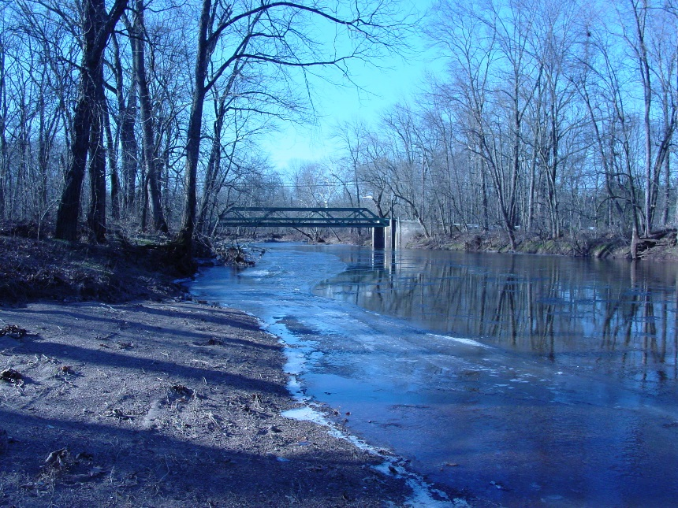

**Join us to learn about the proposal to remove the dam and restore the Lamington River at Raritan Headwater’s Burnt Mills Preserve. Partners will provide an overview of the project, discuss the project design, and answer your questions.**

**Hosted by:**

Raritan Headwaters Association (RHA), Natural Resources Conservation Service (NRCS),

US Fish & Wildlife Service

**This event is free and open to the public.**

Reservations are not required, but will help us plan the event. To RSVP, please contact

Bill Kibler, RHA: bkibler@raritanheadwaters.org or (908) 234-1852, ext. 312.

