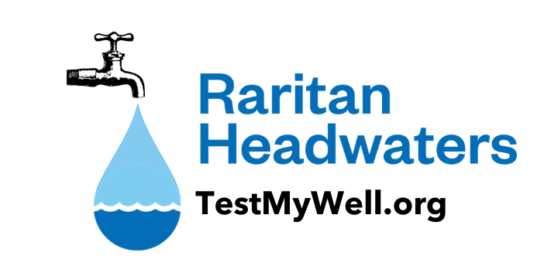
RHA Well Testing Office
124 Main Street, Flemington, NJ
908-234-1852 ext. 401
welltesting@raritanheadwaters.org

Well Testing: Sample Collection Overview and Instructions

***Samples MUST be collected the same morning that they are submitted for testing***

Please read all instructions in advance of the actual sample day. It is IMPERATIVE you follow these instructions exactly to obtain accurate test results. You may visit our website at www.raritanheadwaters.org/well-testing-how-to-take-your-samples/ for helpful instructional videos on taking your water samples. Please call our office if you have any questions.

1. Choose a water source And Prepare the Sample Tap:
- Results will reflect the water quality in your well, or the treated product if you do not bypass any treatment system(s), so it is important to determine where you want to collect your samples. If you want a sample that is most representative of the water in the well, then select a faucet as close to your well as possible (e.g. an outside faucet or a bypass tap near your pressure tank) and be sure to bypass any carbon filters, sediment filters, and water softeners. If you want to know if the treatment system(s) are effective, then sample after any treatment.
- Avoid taking the sample from a swing/swivel type faucet or a faucet that leaks around its stem as that may introduce contaminants into your sample. Exception – lead sample can be taken from the kitchen faucet.
- If you are using an outside tap, disconnect any hoses or other attachments prior to collecting the sample (okay to leave hose on while flushing the pipes in step 2 below but be sure to remove before collecting the sample).
- Remove all aerators and screens from the faucet.

2. Flush the PIPES for 10 minutes: NOTE: Lead and/or Copper samples MUST be taken before the pipes are flushed. See reverse side of sheet for specific instructions on how to collect the lead and/or copper sample.
- Run the cold water at a relatively high flow for 10 minutes to clear the line (want fresh water from the well).

3. Fill the Sample Bottles AND FILL OUT THE TAGS:
- Follow the specific sample instructions on the reverse side of this sheet on how to fill each sample bottle.
- Remember - Samples must be collected the same morning they are being returned.

4. Complete forms:
- Well Test Information Form - Please fill in as much information as possible. Print clearly and be sure to sign the Homeowner Certification on the bottom of form. Indicate whether or not you bypassed any treatment system(s).
- Chain of Custody Form – Please only fill in the yellow highlighted areas on the form.

5. Submit your sample:
- Please return your samples to the location that is indicated on the top of your Community Well Testing Information form. Samples must be returned at the specified time on the date listed on your form.
- Be sure to include completed paperwork, and payment in the form of a check made out to “RHA” if payment was not made at pickup.
Note - Samples should be kept cool and transported in a cooler, with ice or ice packs.

Testing results are typically back from the lab in 3 weeks. Your results will be e-mailed (if email is provided) or mailed (if no email provided). If you do not receive your results within 3 weeks, and you have checked your spam/junk mail folder, please contact us and we will resend them.
Thank you!

INSTRUCTIONS FOR COLLECTING SPECIFIC TESTS
Paying special attention to your preparations and how you handle your Well Test Kit Samples will reduce or eliminate accidental contamination and help avoid inaccurate results or the need to retest your water.
LEAD and/or COPPER
- Lead and/or Copper samples MUST be taken first before all other tests and before you let the water run to flush the pipes. The water should be “sitting” in the pipes overnight (6-8 hours) before you fill the sample bottle.
- Samples should be taken from the primary drinking water source like the kitchen faucet even if it is a swivel faucet.
- Fill the bottle with cold water; cap the bottle tightly & fill out and reattach the tag. Circle the tests you paid for.
COLIFORM BACTERIA (Sealed plastic bottle)
- DO NOT open the sample bottle until you are ready to fill it.
- Sanitize the tap after flushing the pipes for 10 minutes as instructed on page 1 of these instructions:
  - Thoroughly clean the entire area including the basin, faucet, knobs, and counter with an all-purpose cleanser.
- Wash hands with soap.
- Liberally cleanse both the inside and outside of the faucet opening using rubbing alcohol or hold the flame of a match/lighter to both the inside and outside of the faucet opening.
- Run the water for about 15 seconds to clear the faucet of any residue from the match or alcohol.
- When you are ready, break the seal on the coliform bottle and remove the cap, keeping hands away from the inside of the cap or the bottle rim. DO NOT RINSE THE CONTAINER. The bottle contains a small amount of preservative that must remain in the bottle.
- Fill the container to the neck with cold water. DO NOT OVERFLOW. Cap the bottle tightly, fill out & reattach the tag.
NITRATES
- Fill the bottle to the top with cold water; cap the bottle tightly & fill out and reattach the tag.
ARSENIC; IRON; MANGANESE and/or HARDNESS (Plastic bottle)
- Fill the bottle to the top with cold water; cap the bottle tightly & fill out and reattach the tag.
- This bottle can be used for all four tests. Circle the tests you’d like the lab to perform on both the bottle and tag. Please be sure you have paid for the ones you request to be run.
GROSS ALPHA (Plastic bottle in plastic bag with gloves)
- Put on the disposable gloves provided in your kit. This bottle contains Nitric Acid. Avoid skin and eye contact.
- Fill bottle to the top with cold water. Do not overfill and do not pour out excess.
- Cap the bottle tightly, fill out and attach the tag and put back in the plastic bag.
VOLATILE ORGANIC COMPOUNDS (VOC) (3 Glass Vials)
BEFORE STARTING: Be sure there are no sources of Volatile Organics in the room (adjacent rooms) where the sampling is being done. For example, paint, stain, thinners, strippers, and polish could be sources of Volatile Organics. These will be absorbed in the water as the vial is being filled and affect results.
- Read and follow the instructions in the VOC test kit.
- MAKE SURE THERE ARE NO AIR BUBBLES IN THE VIALS ONCE THEY ARE FILLED.
- Fill out and reattach the tag with the rubber band around all three vials.
PESTICIDES (3 Glass Vials with white powder)
- DO NOT RINSE THE VIALS. The white powder preservative must remain in the vials.
- Fill the vials to the top with cold water. DO NOT OVERFLOW.
- Cap the vials tightly & fill out and reattach the tag with the rubber band around all three vials.
RADON
- Read and follow the instructions in the radon test tube. MAKE SURE THERE ARE NO AIR BUBBLES IN THE VIAL.
- Be sure to fill out the small form with your contact information. Place the form and filled vial in the tube.

