Long-term & Recent Trends in Benthic Macroinvertebrate Communities in the Streams of the North and South Branch Raritan Watershed (WMA8), New Jersey, USA, 1992-2017
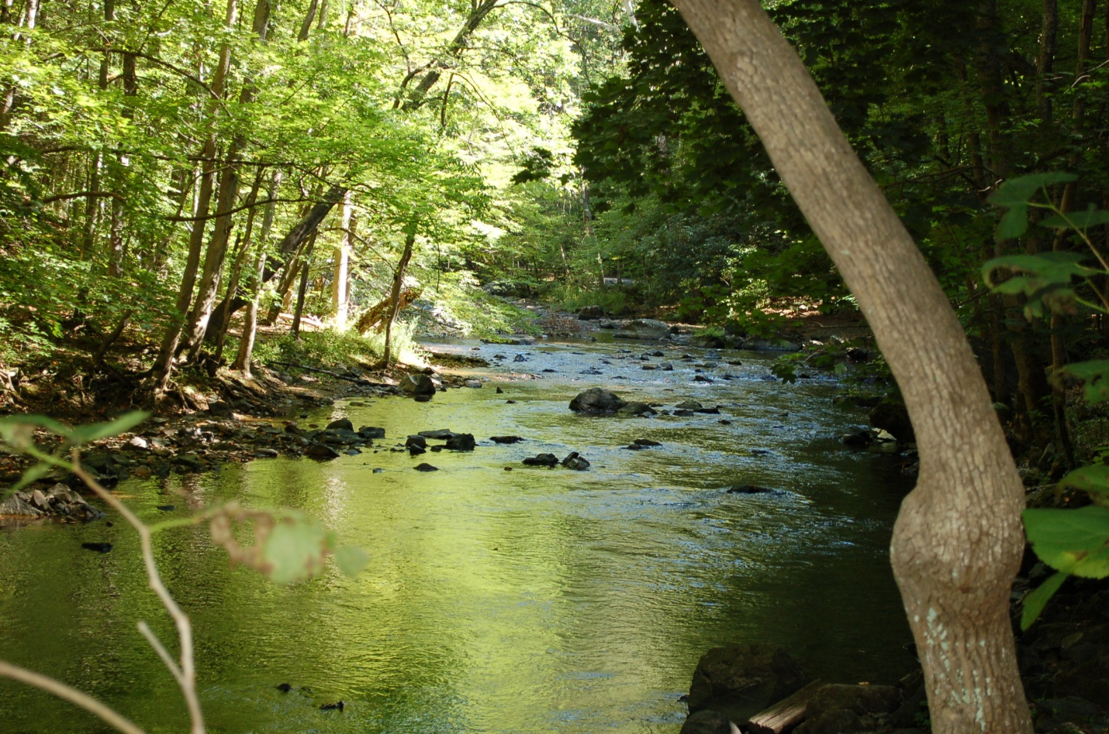

December 2019



Executive Summary
- Raritan Headwaters, a non-profit environmental group founded in 1959 as the Upper Raritan Watershed Association and South Branch Watershed Association, has annually collected high quality data on the benthic macroinvertebrate communities of streams and rivers in the 470 mi2 North and South Branch Raritan River Region (WMA8) of New Jersey over several decades allowing for the analysis of trends in water quality over time.
- Benthic macroinvertebrates, including insects, crustaceans, worms, and mollusks, are used as indicators of water quality because taxa vary in their tolerance of pollution and the presence of sensitive species such as mayflies, stoneflies and caddisflies (EPT species) indicates clean, oxygen-rich, cold water. The High Gradient Macroinvertebrate Index (HGMI) and New Jersey Impairment Score (NJIS) are two indices calculated from benthic macroinvertebrate data used in New Jersey to measure water quality.
- Data on families and genera of benthic macroinvertebrates collected from monitoring sites between 1992 and 2017, and periods in between, were analyzed for trends over time for the watershed overall and combinations of major river (North Branch vs. South Branch) and physiographic province (Highlands vs. Piedmont) using Spearman Rank correlation. In addition, relationships to local habitat, chemical, and land use-land cover parameters were explored.
- For the watershed as a whole, there were no longterm trends in HGMI but NJIS showed a weak positive trend. There has been a positive trend in the number of genera and families, % non-insect genera, pollution tolerant genera and families and % EPT families.
- The more recent time period analyzed (2010-2017) indicated a weak negative trend in HGMI and NJIS. There was a positive trend in the number of families, pollution tolerant families and genera, and % non-insect genera and a negative trend in % EPT families and genera, number of EPT families, and H2 genera.
- Regionally, the North Branch Highlands region experienced the greatest decreases in % non-impaired sites (good and excellent HGMI rating) increases in % impaired sites (fair or poor HGMI rating) but the trend was not as strong as in the North Branch Piedmont. The South Branch sites, both in the Highlands and Piedmont, fluctuated greatly and had a significant percentage of impaired sites but there did not appear to be a distinct pattern with time.
- Most of the sites did not exhibit a significant longterm (83% and 89%) or short-term (89%) trend in HGMI or NJIS over time. There were slightly more longterm and recent positive trends than negative.
- When all macroinvertebrate metrics were tallied for trends indicating improvements to water quality versus trends indicating declines in water quality, the longterm pattern was different than what was detected in recent years. Longterm, 19% of the sites had >1 parameter indicating declines in water quality while 29% of the sites had >1 parameter indicating an improvement in water quality. Whereas in recent years, 26% of the sites had >1 indicator of a decline in water quality while 18% had >1 indicator of improvements.
- Total number correlations….
- HGMI was positively correlated with dissolved oxygen, stream depth, number of stream depth-velocity regimes, epifaunal substrate, embeddedness, % forest cover, % open water and % barren land and negatively correlated with temperature.
- NJIS was positively correlated with % open water and stream depth and negatively correlated with % urban land use.

About Raritan Headwaters
Raritan Headwaters (RHA) is a 501(c)(3) non-profit conservation organization focused on protecting the water quality of the North and South Branch Raritan region, also known as the Upper Raritan (WMA8). The 470-square-mile region provides drinking water to more than 1.5 million residents of 38 municipalities in Hunterdon, Morris, and Somerset Counties and beyond, into the state’s urban areas. RHA resulted from the 2011 merger of two longstanding conservation organizations both founded in 1959, the South Branch (SBWA) and Upper Raritan (URWA) watershed associations.
We know water can no longer be taken for granted. Along with the rest of the world, our region is facing a critical shortage of clean water and a changing climate with stronger, more damaging weather patterns than ever before. The solution begins with recognizing that it is people who determine the health of their environment.
We are dedicated to scientifically monitoring and assessing the health of the water and land in our region. Our “watchdog” alerts are highly effective in notifying residents and local governments of significant issues affecting our water quality. They are also often the instigation of grassroots and local government mitigation actions. We believe in educating residents, landowners, businesses, and government decision-makers about critical watershed protection issues and the innovative tools that can be used to resolve them. The intent of these actions is to motivate stakeholders to help solve these issues together. We speak with one voice to advocate for sound, science-based policies and regulations that ensure and protect clean water for the future.
Our three-pronged approach – science, education, and advocacy – ensures we are basing all of our efforts on scientific fact while empowering and inspiring the community to stand up and defend what is important to them. We are widely recognized by our peers and policymakers as an expert in water and land use issues and a reliable and effective partner.
Benthic macroinvertebrate communities represent long-term physical and chemical conditions in the stream.
Introduction:
Water and Biodiversity
Data on macroinvertebrate communities in streams has long been an accepted indicator of water quality conditions. With the knowledge that stream taxa vary in their physiological requirements and range of tolerance to chemical parameters and physical conditions, several indices of water quality have been developed utilizing samples of stream macroinvertebrate communities. From the sample, species composition, richness, relative abundance and dominance of pollution tolerant and intolerant taxa are used to develop indices of biotic integrity or IBIs. Three families of aquatic macroinvertebrates in particular are sensitive to poor water quality, the Ephemeroptera (mayflies), Plecoptera (stoneflies) and Thrichoptera (caddisflies) or EPT taxa. Two indices developed for New Jersey include the New Jersey Impairment Score (NJIS), which is based on family-level data, and the High Gradient Macroinvertebrate Index (HGMI), which is based on genus-level data.
RHA’s parent organizations, Upper Raritan Watershed Association (URWA) and South Branch Watershed Association, have been monitoring water quality in the region’s streams and rivers since 1959. The current stream monitoring program, which utilizes strict protocols and a team of citizen scientists trained by RHA staff, conducts annual monitoring at permanent locations since 1992. Macroinvertebrates that live in the streams are collected from riffles and sent to a lab where expert taxonomists identify the organism to genus and in some cases species level. In our watershed, we use the state IBI, the New Jersey Impairment Score (NJIS), a statewide metric, and the High Gradient Macroinvertebrate Index (HGMI), a metric developed for streams in the Highlands and Ridge and Valley physiographic provinces of NJ (check). Additional data on habitat quality in and around the stream is collected using rapid visual assessment techniques (NJDEP and USEPA), parameters including temperature, turbidity, specific conductance, pH, dissolved oxygen, nutrients and E. coli are tested, and ArcGIS is used to calculate the percentage land use and land cover within the catchment draining into each monitoring site.
The macroinvertebrate community, when studied over long periods of time, represents conditions in the stream over long periods of time. Thus, measuring this community of organisms is a summary of many changes that may have occurred in chemistry, habitat, and landscape-scale factors over time. Because the data are collected using the same methods and at the same sites each year, it is possible to look for long-term trends. By examining changes in water quality over time we can: (1) target specific areas in the watershed where problems exist for more detailed monitoring and restoration; (3) address the causes of water quality or habitat decline and/or improvement; (4) identify trends associated with extreme weather events such as floods and droughts; and (5) improve the prediction of future trends.
Bill - With enactment of The Clean Water Act (1970), NEPA, and other environmental regulations protecting water, we would expect to see mainly improvements in water quality over time. However, many of the stressors that impact water quality including increases in urban land use and loss of forest and wetland could counteract impact we would expect. In addition, while regulations have greatly helped with point source pollution, many non-point sources continue to go unregulated.
Methods:
Study area
The drainage basin of the entire Raritan River covers approximately 1,100 square miles, making it the largest river basin located entirely within the State of New Jersey. The South Branch of the Raritan River is 51 miles long from its source in Budd Lake to its confluence with the North Branch in Branchburg. The North Branch of the Raritan River originates as a spring-fed stream in Morris County and flows south for approximately 23 miles to its confluence with the South Branch. The Raritan River empties into Raritan Bay on the Atlantic Ocean.

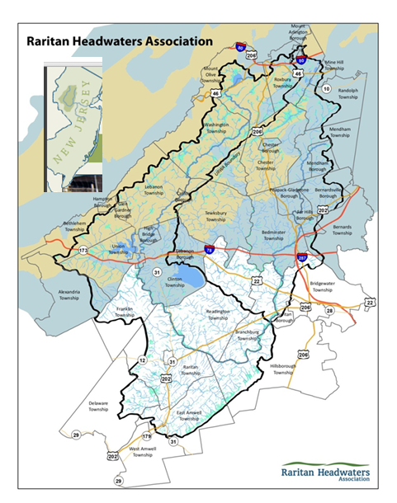
Need new map with updated logo
Add Figure showing summary of major weather years
The North and South Branch Raritan Watershed (WMA8; Figure 1) is the largest watershed within the Raritan River Basin and the New Jersey Highlands Region, the source of clean drinking water for more than half the state’s population. The 470 mile² watershed, which comprises the Raritan Headwaters region, provides well water to the residents of 38 municipalities in Hunterdon, Morris and Somerset counties and drinking water to more than 1.5 million residents that live beyond our watershed, into the state’s urban areas. The South Branch of the Raritan River is 51 miles long, from its source in Budd Lake to its confluence with the North Branch. The North Branch originates as a spring-fed stream in Morris County and flows south approximately 23 miles to its confluence with the South Branch in Branchburg. The watershed holds a rich variety of flora and fauna and contains some 1,400 miles of stream, including many wild trout production streams. Two large reservoirs, Spruce Run and Round Valley, and a variety of large protected public lands including Ken Lockwood Gorge, Hacklebarney State Park, and the Black River Wildlife Management Area are all within the Raritan Headwaters region. Under the surface, are the fractured-rock aquifers of the Newark Basin including mainly the Brunswick aquifer, Lockatong and Stockton formations (Herman et al. 1998), along with some limestone aquifers and buried valley aquifers where glaciers deposited sand, gravel and clay materials. These resources are threatened by continued degradation caused by numerous stressors associated with human activities.
Figure 4 is a map of 2012 land use and land cover in the watershed. There have been great changes in land use in the watershed over the past two decades, which included an increase in urban/suburban land use replacing farmland and forestland. Between 1995 and 2012, urban land cover increased from 80,349 acres to 97,789 acres (a net change of 17,440 acres) and agriculture decreased from 75,179 acres to 62,960 acres (a net change of -12,219 acres; NJDEP). Forest cover decreased from 108,571 acres to 104,619 acres (a net change of -3,952 acres). Protection of remaining forest and wetlands in this headwater region is critical to maintaining surface and groundwater quality.

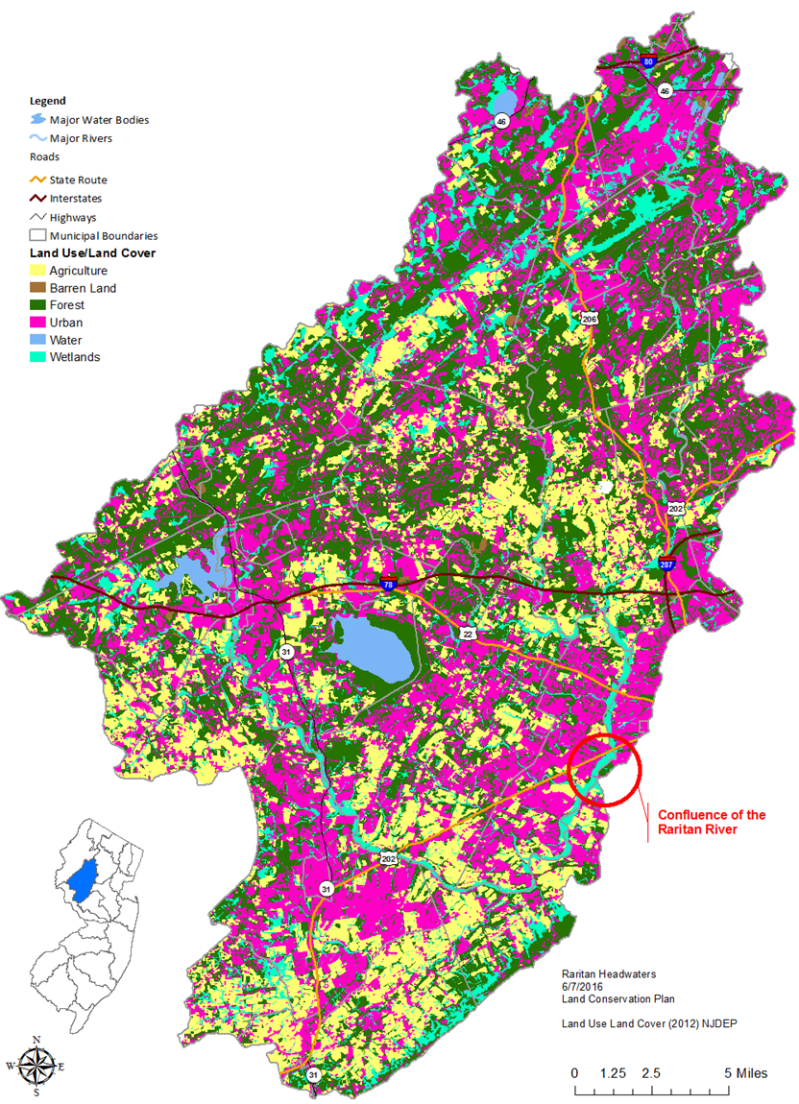

Data Collection
Visual and biological stream assessments are performed annually between June 15th and July 10th. By using the same sampling window each year the information gathered can be easily compared to archived data. Stream monitoring sites have been chosen so that they are suitable to use with the U.S. Environmental Protection Agency’s Rapid Bioassessment protocol. The protocol RHA uses is briefly described below.

Volunteers characterize the health of the riparian habitat by completing a visual site assessment and calculating stream flow. To collect a biological sample, volunteers use a net to perform a “kick” in the stream, disturbing the benthic habitat in a particular riffle so that all cobble, sand, and debris flow into the net. Once completed, volunteers sort through the collected debris, removing all benthic macroinvertebrates and preserving them in a jar of ethyl alcohol. These jars are clearly labeled using stream monitoring site ID numbers, and are sent to a certified laboratory to identify all macroinvertebrates collected down to the species level when possible. Analysis by an independent lab assures that RHA’s data is of the highest quality, allowing it to be used by agencies with even the most stringent data quality requirements.

Please note that in 2011, SBWA’s protocol and URWA’s protocol for collecting their biological samples differed slightly. SBWA used an 18” x 8” kick net with a 900 micron mesh size to sample one riffle for 2 or 5 minutes while URWA used a D-frame dip net with 500 microns mesh size to sample 10 different riffles at a stream site for 1 minute each. In 2012, volunteers collected biological samples using one unified protocol. All volunteers used a D-frame dip net with a 500 micron mesh size to sample one riffle for five minutes. We converted to 10, 1-minute kick samples, within a 100m stretch stream???

The benthic macroinvertebrate samples are scored using the New Jersey Impairment Scoring (NJIS) Criteria for Rapid Bioassessments. This protocol evaluates a 100 organism subsample on five criteria: Taxa Richness, EPT families, Percent Dominance, Percent EPT, and Family Biotic Index (FBI). Each of the five metrics is given a score of 0, 3, or 6 depending on where it falls on the scale, and then all are totaled for a final NJIS index score. The possible scores range from 0 to 30, where 30 indicates the high end of non-impaired and 0 indicates a site which is severely impaired. For more information regarding metric parameters and scoring, please see Appendix C.

In order to assure that our methods are up to date, RHA submits a QAPP to the NJDEP Division of Water Monitoring and Standards for review and approval annually. Before the monitoring season, all monitoring equipment is inventoried, calibrated, and replaced if necessary.

Each spring, RHA staff and an Americorps Ambassador hold a stream monitoring training that is open to new and returning volunteers. This training reviews the purpose of the stream monitoring program and assures the standardization of sample and data collection by explaining and demonstrating the biological sampling and visual assessment protocols.

Get rid of line at bottom of page.
For each stream monitoring site RHA provides to all volunteers GPS coordinates, verbal descriptions of collection (riffle) areas, and photographic records. This further assures that comparable data is gathered from one year to the next. GPS coordinates and site descriptions are available on RHA’s website at http://www.raritanheadwaters.org/protect/stream-monitoring-program/stream-monitoring-map/.
Need updated site map including current and retired sites
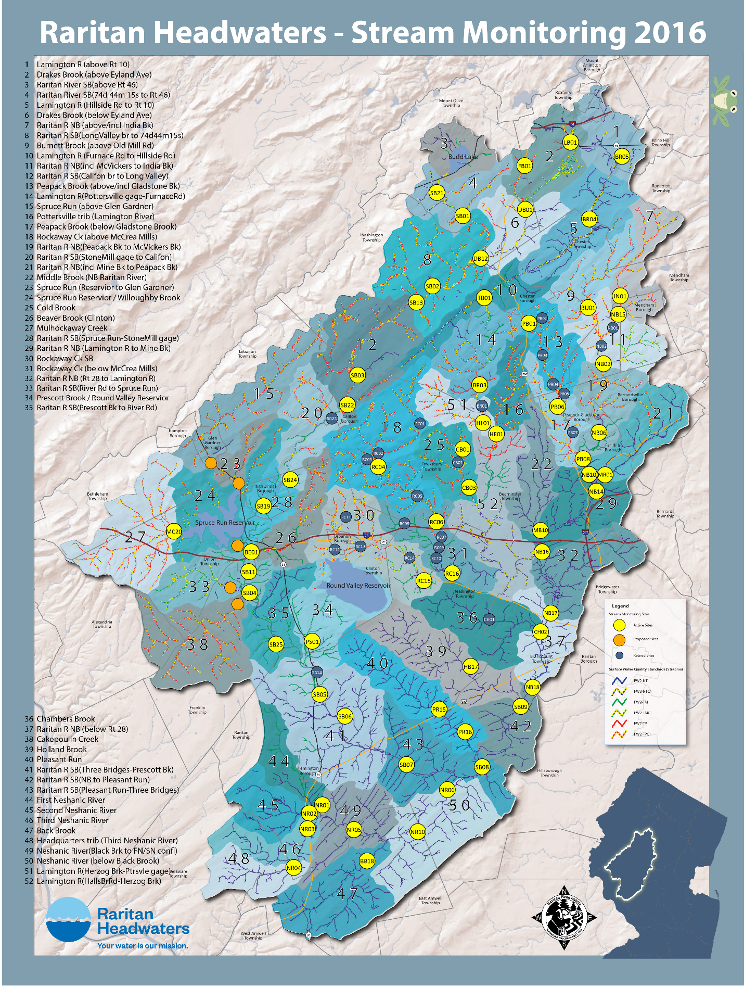

NJ High Gradient Macroinvertebrate (HGMI) score
NJDEP developed a new tool for identifying biological degradation in the high gradient streams of New Jersey: the High Gradient Macroinvertebrate Index (HGMI). Two forms of the index were developed, one for application with genus level taxonomy and one for family level data. RHA identifies organisms to genus and species level when possible thus the HGMIgen is calculated. As part of the HGMI, seven metrics are calculated and scored for inclusion in the index: • Total number of genera • Percent of genera that are not insects • Percent of EPT individuals (excluding Hydropsychidae, including Diplectrona) • Number of scraper genera • Hilsenhoff Biotic Index • Number of attribute 2 genera (highly sensitive and uncommon taxa) • Number of attribute 3 genera (sensitive and common taxa)
A suite of commonly applied, empirically proven, and theoretically responsive metrics was calculated for possible inclusion in a multimetric index. Tolerance metrics were based on both Hilsenhoff tolerance values and Biological Condition Gradient (BCG) taxa attribute groups (Davies and Jackson 2006; Gerritsen and Leppo 2005). Hilsenhoff tolerance values are on a 0 to 10 scale (most sensitive to most tolerant). The Hilsenhoff scale was derived primarily to address taxa tolerance to organic pollutants (Hilsenhoff 1987). Attributes associated with taxa for BCG analysis range from sensitive-endemic to pollution tolerant. BCG attributes were assigned to taxa by consensus during a workshop on assessment of New Jersey’s wadeable streams (Gerritsen and Leppo 2005). Several metrics describe richness and composition of Ephemeroptera, Plecoptera, and Trichoptera (EPT; mayflies, stoneflies, and caddisflies) insects. High Gradient Macroinvertebrate Index 13 Tetra Tech, Inc. All richness metrics (e.g., insect taxa and non-insect taxa) were calculated such that only unique taxa are counted. Those taxa that were identified at higher taxonomic levels because of damage or under-developed features were not counted as unique taxa if other individuals in the sample were identified to a lower taxonomic level within the same sample. Genus level taxonomy was expected to provide more responsive metrics, so all metrics were calculated at the genus level. Metrics that performed well or were previously part of the NJIS were also calculated at the family level. Metrics were not calculated at the species level because several specimens were not identified below genus. Collapsing to genus level provides greater taxonomic consistency, though species level attributes are lost. Habit metrics were calculated using insect taxa only. Habit attributes were not assigned to non-insects by NJDEP. Metrics were calculated in a relational database. Once calculated, the metrics were imported into the statistical package Statistica for further analysis.
Make this a table: Macroinvertebrate Index for High Gradient Streams (HGMI Metric)
(Highlands, Ridge and Valley, Piedmont Physiographic Provinces)
Category Metric Score Assessment
Excellent 63 - 100 Not Impaired
Good 42 - < 63 Not Impaired
Fair 21 - < 42 Impaired
Poor < 21 Impaired

New Jersey Impairment Score Calculation

The benthic macroinvertebrate samples are scored using the New Jersey Impairment Scoring (NJIS) Criteria for Rapid Bioassessments. This protocol evaluates a 100 organism subsample on five criteria: Taxa Richness, EPT families, Percent Dominance, Percent EPT, and Family Biotic Index.

- Taxa Richness refers to the total number of macroinvertebrate families found at the stream monitoring site; a more diverse sample typically indicates a healthier site.

- “EPT Families” refers to the total combined number of organisms in the sample that belong to the Ephemeroptera (mayflies), Plecoptera (stoneflies), and Tricoptera (caddisflies) families. Generally, the presence of more EPT families indicates a healthier site.

- Percent Dominance refers to the proportion of the total sample comprised of the dominant family; a smaller percentage of the total sample dominated by one family indicates a healthier site.

- Percent EPT refers to the proportion of the total sample comprised of EPT organisms. A greater percentage of the total sample comprised of EPT organisms indicates a healthier site.

- Family Biotic Index (FBI) represents the summation of the following calculation: The number of individuals within a family is multiplied by the Hilsenhoff Family Tolerance Value, and this number is then divided by the total number of organisms in the sample. A lower biotic index value indicates a healthier site.

Each of the five metrics is given a score of 0, 3, or 6 depending on where it falls on the scale, and then all are totaled for a final NJIS index score. The possible scores range from 0 – 30 where 30 indicates the high end of non-impaired, and 0 indicates a site which is severely impaired.

Index metrics | 6 | 3 | 0
Taxa Richness (Total Families) | >10 | 10-5 | 4-0
E+P+T Index (EPT) | >5 | 5-3 | 2-0
Percent Dominance | <40 | 40-60 | >60
Percent EPT | >35 | 35-10 | <10
Modified Family Biotic Index | <5 | 5-7 | >7

The biological conditions and their attributes are discussed below:

Non-impaired: Total Score: 24 – 30. Benthic community is comparable to other undisturbed streams within the region. A community characterized by a maximum of taxa richness, balanced taxa groups, and good representation of intolerant species.

Moderately Impaired: Total Score: 9 – 21. Macroinvertebrate richness is reduced in particular EPT taxa. Taxa composition changes result in reduced community balance and intolerant taxa become absent.

Severely Impaired: Total Score: 0 – 6. A dramatic change in the benthic community has occurred. Macroinvertebrates are dominated by a few taxa which are very abundant. Tolerant taxa are the only individuals present.

Statistical Analysis
NJIS, HGMI, and several of the underlying macroinvertebrate community metrics were summarized by mean, range and standard deviation. Spearman rank correlation of macroinvertebrate community metrics with year was used to determine direction and significance of trend over time. Once spatial and temporal patterns were identified, further exploration of possible causal mechanisms were explored including the influence of local chemical or physical conditions as well as landscape scale variables such as land use, land cover and catchment area.
Macroinvertebrate community parameters can fluctuate with major variations resulting from a major storm or drought, and observing short-term observations of water quality alone do not provide an adequate information because they are often able to return to previous….

Results:
Current Status
Macroinvertebrate Community Characteristics – Total Species, # of species in each taxon (Insect: Diptera, Trichoptera, Ephemeroptera, Plecoptera, and Coleoptera and Non-insect: Mollusca, Crustacea, worms). Variability of taxa richness, range in data set richness, 25 percentile, median, 75 percentile and outliers. Median and Range in NJIS, HGMI, Number EPT, %EPT, richness, diversity, jaccard, bray-curtis.
Raritan Headwaters, a regional non-profit watershed association in northern New Jersey, has been collecting data on benthic macroinvertebrate communities to assess water quality since 1992. This robust program utilizes trained citizen scientists to annually monitor 63 stream sites throughout the 1,217 km² Upper Raritan Region that includes the North and South branches of the Raritan River. Data spanning 25 years, from 1992-2017, were analyzed for spatial and temporal trends in biological indices of water quality. Long-term trend analyses in general provide an opportunity to detect gradual changes, study changes due to multiple stressors, and study response and recovery from rare or extreme disturbances.
Spearman rank correlation of macroinvertebrate community and pollution tolerance metrics with year was used to determine direction and significance of trend over time. As part of the process of analyzing the data, several issues had to be addressed because along with the opportunities associated with long-term data, there are often obstacles including changing locations, time periods, goals, and methods. One solution was that sites had to be grouped based on the length of time in the program as well as their location in the watershed. Two long-term analyses included sites that spanned 1992-2017 and 2002-2017 and 4 shorter periods within those time frames were analyzed. In addition, sites were categorized into one of two main branches (North and South Branch Raritan) and by physiographic province (Highland and Piedmont) as well as a combination of both categories for subsequent analysis in all time periods.

Descriptives
Mean, SD, range of HGMI. Each site in appendix??

Figure: Box Plots of all stream monitoring site results depicting HGMI median, percentiles, max and min for all years combined for each site.

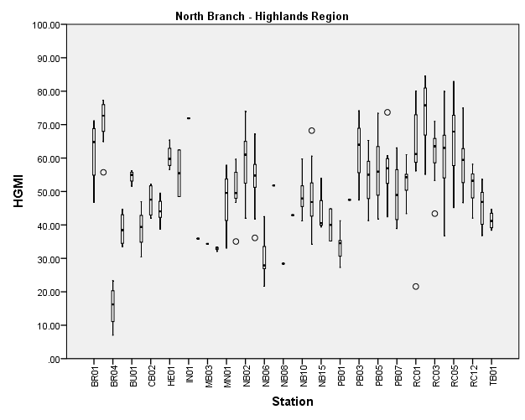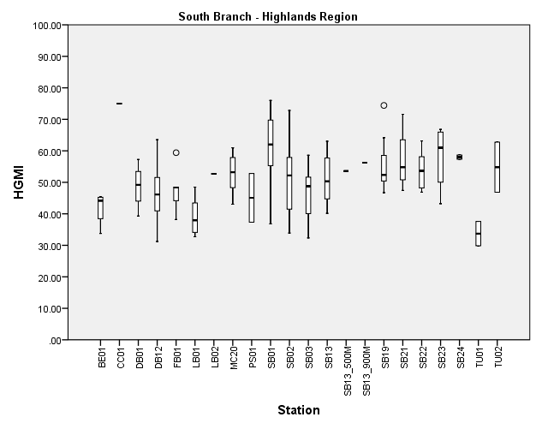

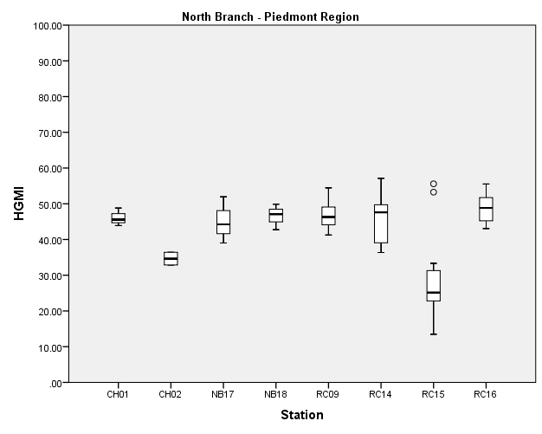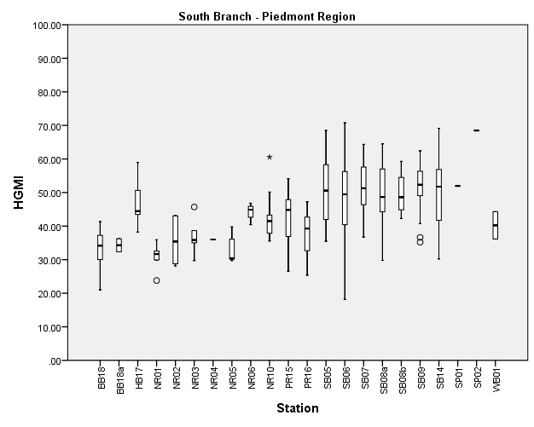

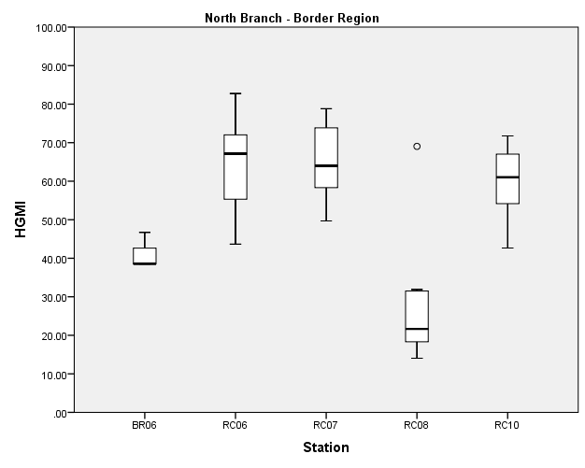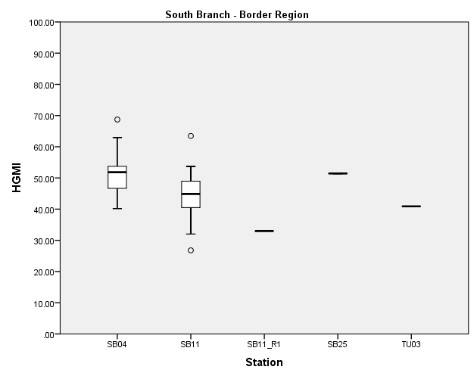

Trends over Time
By Site

Number of total positive correlations, negative correlations of time with macroinvertebrate variables were detected. The two long-term analyses (1992-2017 and 2002-2017) including all sites in the watershed indicated most of the sites (83%, and 89%, respectively) showed no trend in HGMI or NJIS, 14% and 9% showed a positive trend, and 9% and 4% showed a negative trend in water quality. When sites were combined in an overall analysis for that time period, there were several weak trends detected, mainly in the sub-metrics such as increasing taxa richness, increasing non-insect taxa, and increasing pollution tolerant taxa. Forty-five sites that spanned the period 2002-2017 demonstrated a similar pattern of trends.
Trends in Water Quality by Site Grouped by Time Period

Time Period | Total # of Sites | Percentage and number of Sites with Each Trend in HGMI (or NJIS) |  |  | # of Sites with a count of >1 community parameter trend (other than HGMI, NJIS, or Richness)
 |  | Positive | Negative | No Trend | Positive | Negative | Both | No Trend
Longterm 1992-2017 | 35 | 14.3(5) | 8.6(3) | 82.9(29) | 21.6(8) | 40.5(15) | 18.9(7) | 18.9(7)
Longterm 2002-2017 | 47 | 8.5(4) | 4.3(2) | 89.4(42) | 29.1(14) | 18.8(9) | 10.4(5) | 41.7(20)
1992-1999 | 13 | 15.4(2) | 0(0) | 84.6(11) | 23.0(3) | 0(0) | 0(0) | 76.9(10)
2000-2004 | 43 | 11.6(5) | 9.3(4) | 79.1(34) | 25.6(11) | 25.6(11) | 11.6(5) | 37.2(16)
2005-2009 | 41 | 14.6(6) | 7.3(3) | 78.0(32) | 18.4(9) | 29.3(12) | 2.4(1) | 46.3(19)
2010-2017 | 62 | 6.4(4) | 4.8(3) | 88.7(55) | 17.7(11) | 25.8(16) | 8.1(5) | 48.4(30)

Maps of Longterm Trend Analysis Results by Monitoring Sites from 1992-2017 and
2002-2017.

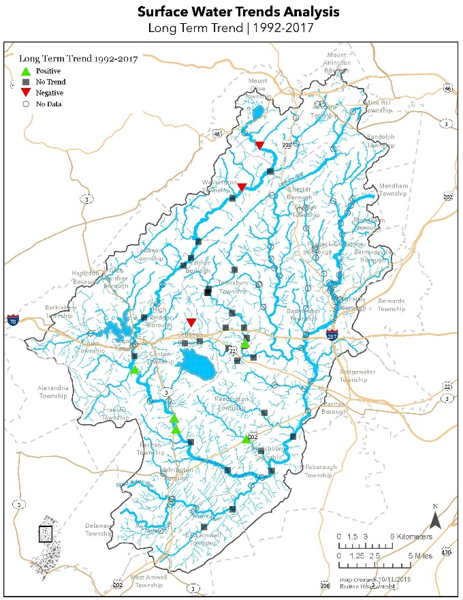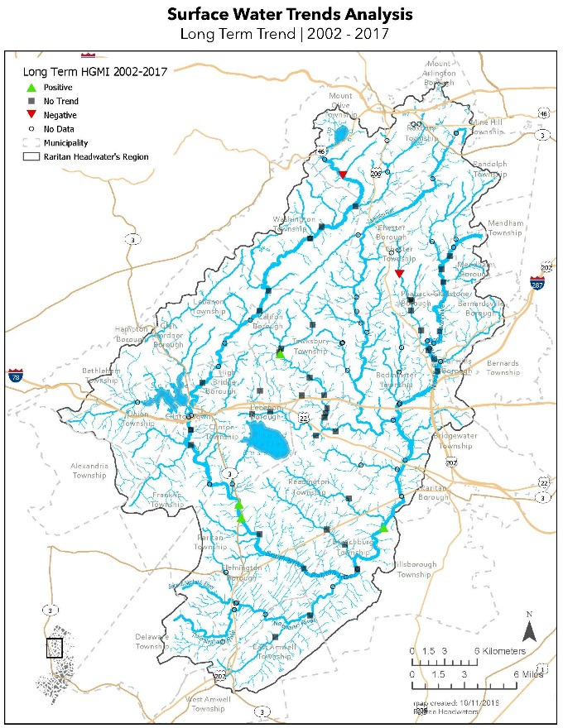
Positive: PR15, SB04, SB05, SB14 Positive: RC04, SB05, SB09, SB14
Negative: RC11, SB01, SB02 Negative: PB03, SB01

Trends by shorter time periods

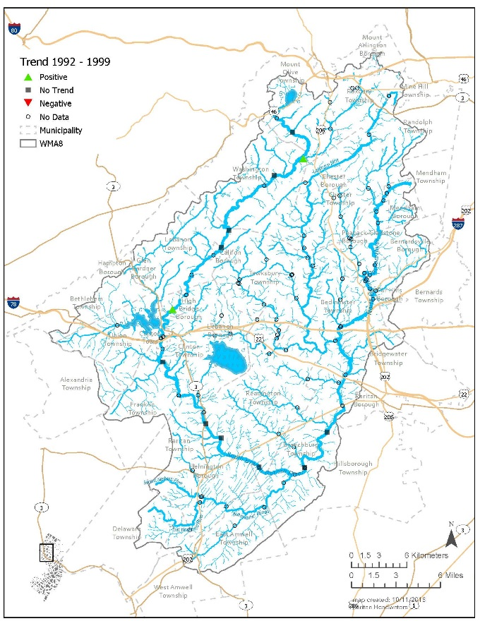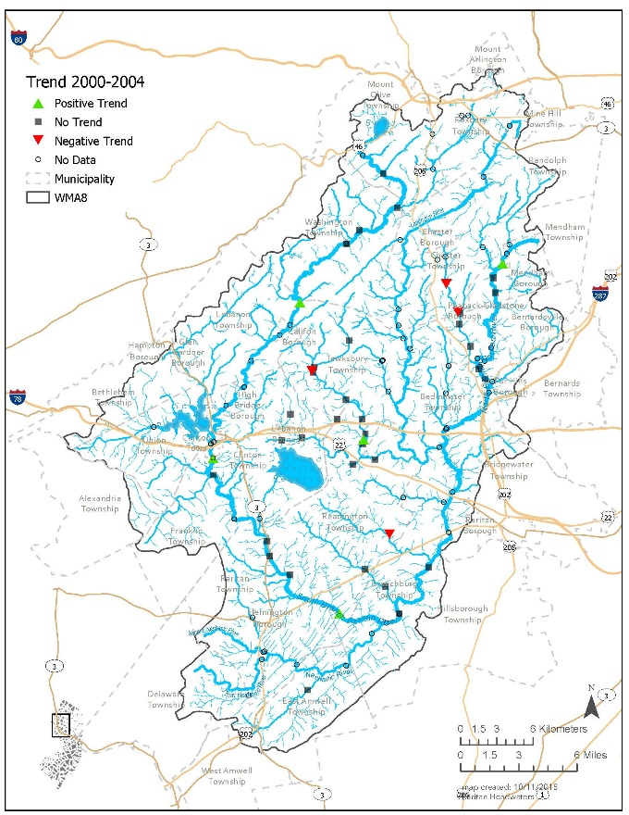
Positive: DB12 and SB19 Positive: NB01, RC09, SB03, SB07, SB11
Negative: PB03, PB04, RC03, RC09

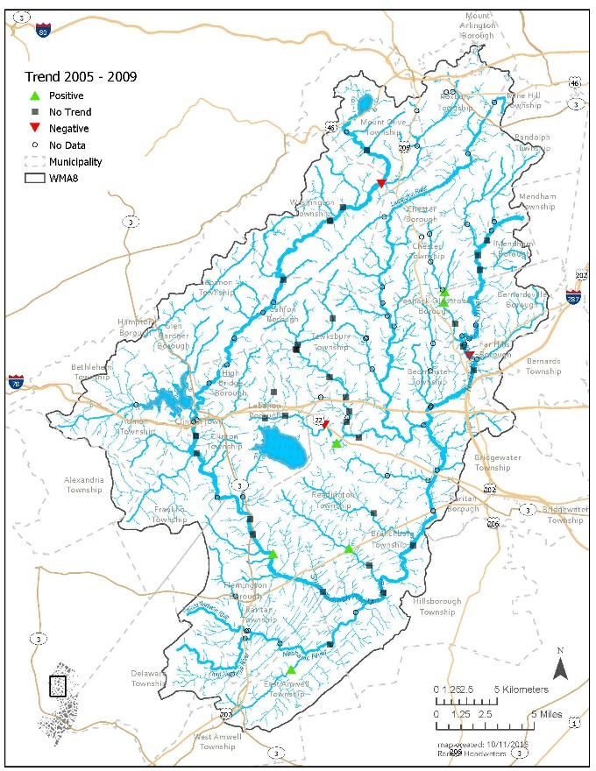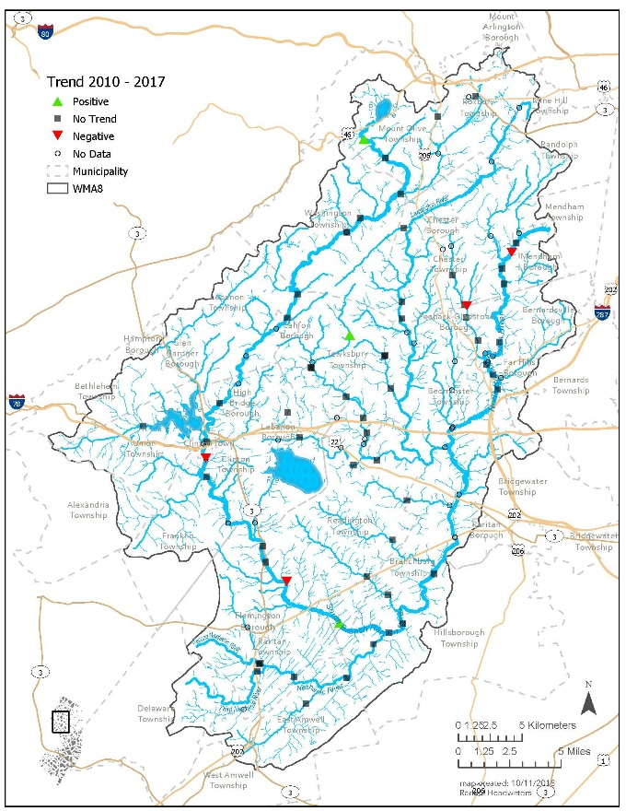
Positive: BB18, PB05, PB06, PR15, SB06, RC15 Positive: RC01, SB07, SB21
Negative: DB12, NB10, RC14 Negative: PB05, NB01, SB06, SB11

Discuss Patterns in time periods.

Trends Over Time Overall and Regional

Overall, water quality in the North Branch declined whereas the South Branch has improved. Both the Highland and Piedmont have experienced overall declines. While there were negative trends in the earlier time period (1992-1999) most of the more striking and numerous trends of declining water quality have taken place more recently (2010-2017). Subsequent to two catastrophic storms in the region, Tropical Storm Floyd in 1999 and Hurricanes Irene and Sandy in 2011 and 2012 respectively, there were sharp increases in the number of impaired sites the following sampling period. In earlier years, the number of impaired sites rapidly dropped as apparently benthic macroinvertebrate communities recovered. Post Hurricane Sandy, sites have not yet recovered to pre-Sandy macroinvertebrate conditions. Declines were also concentrated in the Highlands region when physiographic province was included for both the North and South Branches. The Highlands region provides drinking water to 1.5 million people in cities in northern NJ so this trend indicates a direct health effect.

All Site Combined
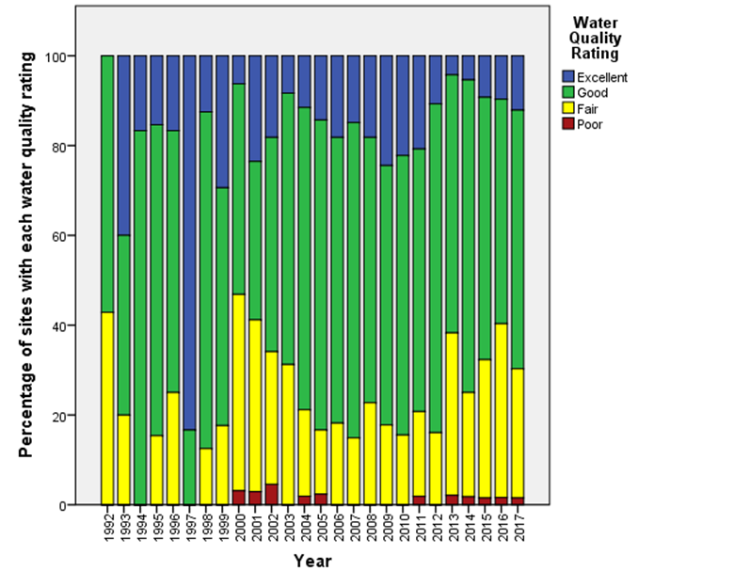

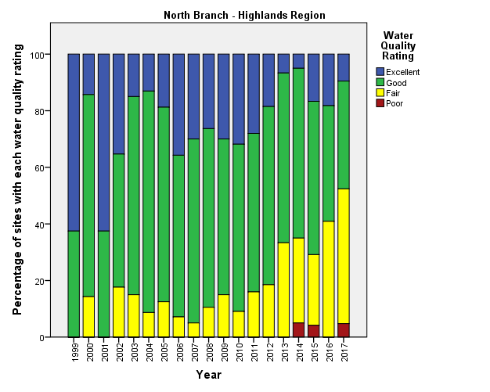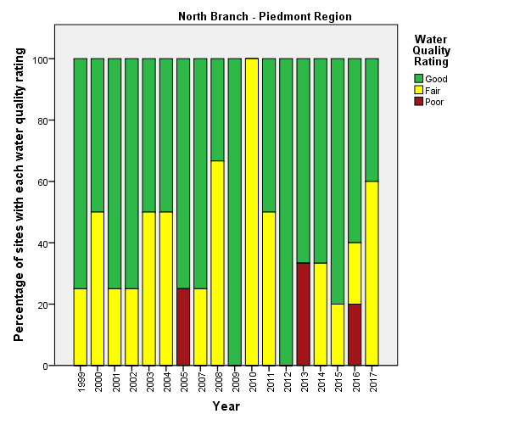

In the North Branch-Highlands there was an increasing proportion of Fair-Poor and a decreasing proportion of good sites since 2010. There has always been a fairly high proportion of fair-poor and good sites in the North Branch- Piedmont sites. There have never been sites achieving excellent ratings during the years monitored.

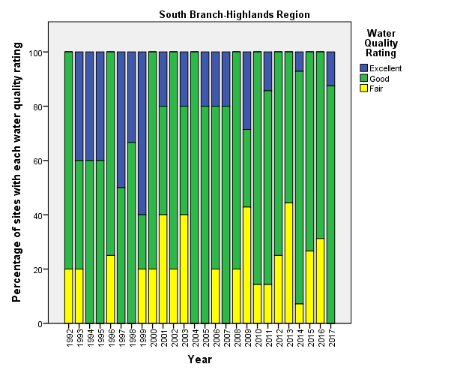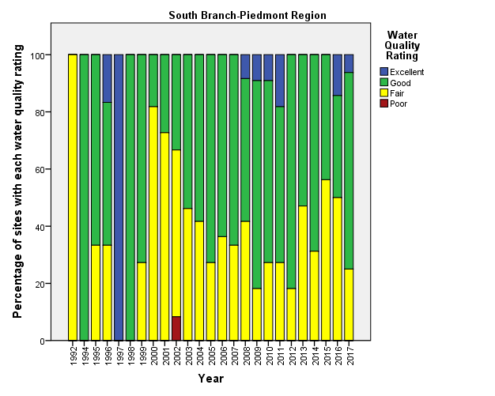

South Branch-Highlands sites appeared to have more sites rated as excellent prior to 2000. Since 2010, sites have fluctuated greatly in the number of fair sites. South Branch-Piedmont region had a very high spike in the proportion of fair sites around 2000. The proportion of fair sites gradually fell and there was a high proportion of excellent-good sites aroun 2009-2012 then there was a higher proportion of fair sites since then.

Indicator Associated with | _ | _ | _ |  | + | + | +
Trend | Moderate | Weak | Very Weak | No Trend | Very Weak | Weak | Moderate
Range of Spearman Rank Correlations | -0.40-0.59 | -0.20- -0.39 | -0.00 - -0.19 |  | 0.00 – 0.19 | 0.20 – 0.39 | 0.40 – 0.59
Color

All Site Combined watershed-wide for each time period, respectively, Spearman Rank Correlation Coefficients at p<0.05 and p<0.01.
Macroinvertebrate Community Metric | Longterm 1992-2017 | Longterm 2002-2017 | 1992-1999 | 2000-2004 | 2005-2009 | 2010-2017
HGMI |  |  |  | 0.144* |  | -0.205**
NJIS |  | 0.101* |  |  |  | -0.184**
Family Richness | 0.238** | 0.275** |  |  | 0.227** | 0.151**
EPT Family Richness | 0.104** | 0.113** |  |  |  | -0.171**
% EPT Families |  |  |  |  |  | -0.191**
FBI | 0.166** | 0.158** |  |  |  | 0.184**
% Dominance Family
Genera Richness | 0.290** | 0.313** |  |  | 0.218**
%Dominant Genera | -0.188** | -0.177**
%Non-insect Gen. | 0.259** | 0.292** |  |  | 0.220** | 0.334**
% Sensitive EPT Gen. |  |  | -0.339* | 0.155* |  | -0.185**
HBI Species | 0.186** | 0.193** | 0.305* |  |  | 0.234**
# Scrapers |  | 0.144**
H2 Genera |  |  |  |  |  | -0.225**
H3 Genera |  |  |  | 0.180*

All Sites Combined for the North Branch in each time period, respectively, Spearman Rank Correlation Coefficients at p<0.05 and p<0.01.
Macroinvertebrate Community Metric | Longterm 1992-2017 | Longterm 2002-2017 | 1992-1999 | 2000-2004 | 2005-2009 | 2010-2017
HGMI |  |  |  |  |  | -0.225**
NJIS |  |  |  |  |  | -0.239**
Family Richness | 0.180** | 0.141** |  |  | 0.232*
EPT Family Richness |  |  |  |  |  | -0.191**
% EPT Families | 0.152* |  |  |  |  | -0.250**
FBI |  | 0.135* |  |  |  | 0.248**
% Dominance Family
Genera Richness | 0.142* | 0.205** |  |  | 0.223*
%Dominant Genera
%Non-insect Gen. | 0.364** | 0.298** |  |  | 0.371** | 0.384**
% Sensitive EPT Gen. |  |  |  |  |  | -0.335**
HBI Species |  | 0.185** |  |  |  | 0.307**
# Scrapers |  |  |  |  |  | 0.195*
H2 Genera |  |  |  |  |  | -0.346**
H3 Genera |  | -0.111*

All Sites Combined for the South Branch in each time period, respectively, Spearman Rank Correlation Coefficients at p<0.05* and p<0.01**.
Macroinvertebrate Community Metric | Longterm 1992-2017 | Longterm 2002-2017 | 1992-1999 | 2000-2004 | 2005-2009 | 2010-2017
HGMI |  | 0.163** |  | 0.245* |  | -0.160*
NJIS |  | 0.212** |  |  |  | -0.140*
Family Richness | 0.266** | 0.438**
EPT Family Richness | 0.135** | 0.256**
% EPT Families
FBI | 0.212** | 0.132* |  | -0.256*
% Dominance Family |  | -0.176**
Genera Richness | 0.355** | 0.444**
%Dominant Genera | -0.229** | -0.306**
%Non-insect Gen. | 0.218** | 0.232** |  |  |  | 0.267**
% Sensitive EPT Gen. | 0.099* | 0.249** | -0.339**
HBI Species | 0.226** | 0.147* | 0.305* |  |  | 0.145*
# Scrapers |  | 0.123*
H2 Genera | 0.102*
H3 Genera

All Sites Combined for the Highlands Region in each time period, respectively, Spearman Rank Correlation Coefficients at p<0.05 and p<0.01.
Macroinvertebrate Community Metric | Longterm 1992-2017 | Longterm 2002-2017 | 1992-1999 | 2000-2004 | 2005-2009 | 2010-2017
HGMI | -0.171** | -0.139** |  |  |  | -0.184**
NJIS |  |  |  |  |  | -0.186**
Family Richness |  | 0.155** |  |  | 0.256** | 0.228**
EPT Family Richness |  |  |  |  |  | -0.141*
% EPT Families |  |  | -0.416* |  |  | -0.258**
FBI | 0.217** | 0.229** |  |  |  | 0.225**
% Dominance Family
Genera Richness | 0.263** | 0.238** |  |  |  | 0.202**
%Dominant Genera | -0.278** | -0.173**
%Non-insect Gen. | 0.375** | 0.382** |  |  | 0.282** | 0.388**
% Sensitive EPT Gen. | -0.183** |  | -0.597** |  |  | -0.257**
HBI Species | 0.308** | 0.300** | 0.440* |  | 0.207* | 0.265**
# Scrapers |  | 0.116*
H2 Genera |  | -0.160** |  |  |  | -0.256**
H3 Genera |  | -0.148**

All Sites Combined for the Piedmont Region in each time period, respectively, Spearman Rank Correlation Coefficients at p<0.05 and p<0.01.
Macroinvertebrate Community Metric | Longterm 1992-2017 | Longterm 2002-2017 | 1992-1999 | 2000-2004 | 2005-2009 | 2010-2017
HGMI |  | 0.173* |  |  |  | -0.234**
NJIS | 0.182** | 0.244** |  |  |  | -0.217*
Family Richness | 0.328** | 0.431**
EPT Family Richness | 0.168** | 0.245** |  |  |  | -0.186*
% EPT Families | 0.170** | 0.145*
FBI | 0.193** | 0.156*
% Dominance Family
Genera Richness | 0.345** | 0.410**
%Dominant Genera | -0.191** | -0.184**
%Non-insect Gen. | 0.190** | 0.218** |  |  |  | 0.253**
% Sensitive EPT Gen. | 0.286** | 0.303**
HBI Species | 0.129* |  |  |  |  | 0.191*
# Scrapers | 0.142* | 0.216** | 0.431*
H2 Genera
H3 Genera |  |  |  |  |  | -0.198*

Individual Macroinvertebrate Metrics Over Time
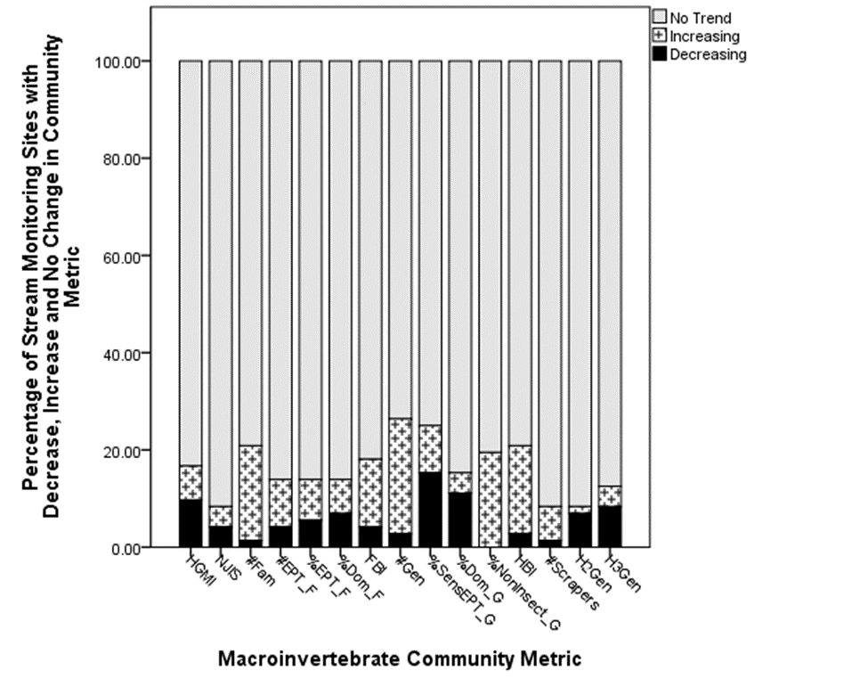

REDO THIS SERIES OF BOX PLOTS GRAPH FOR NEW DATA

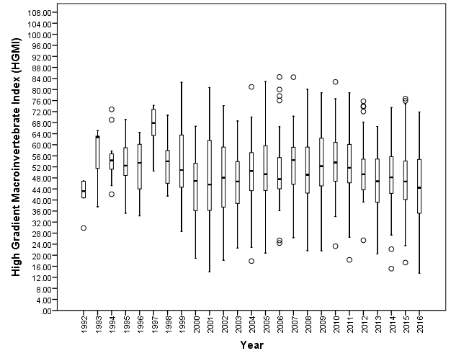

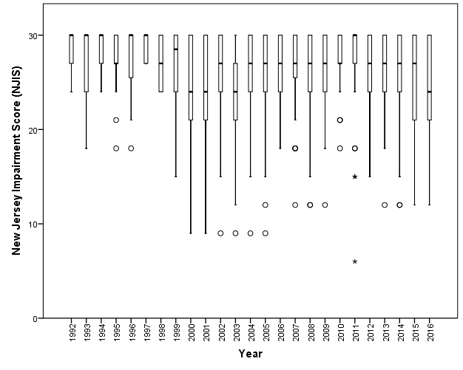

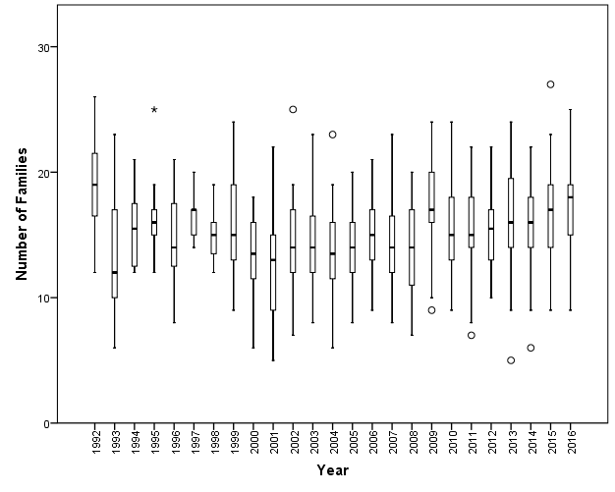

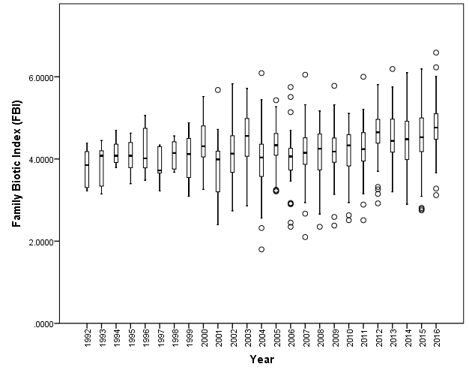

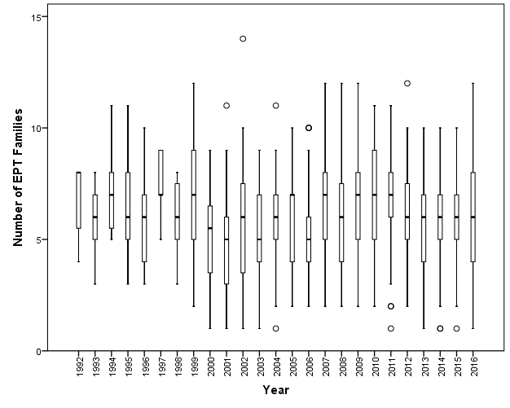

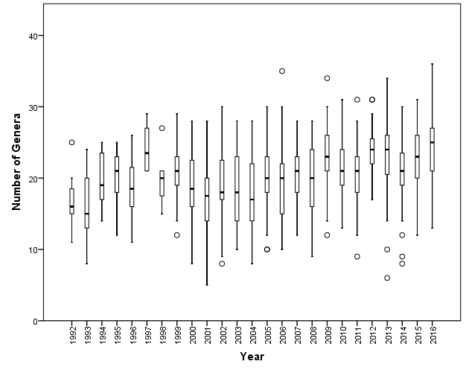

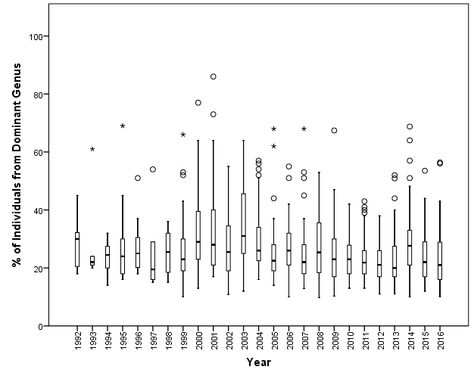

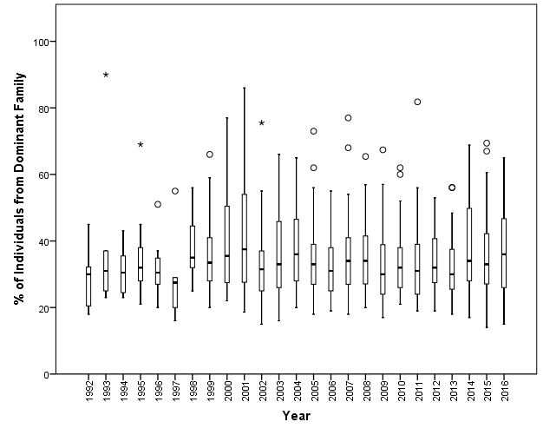

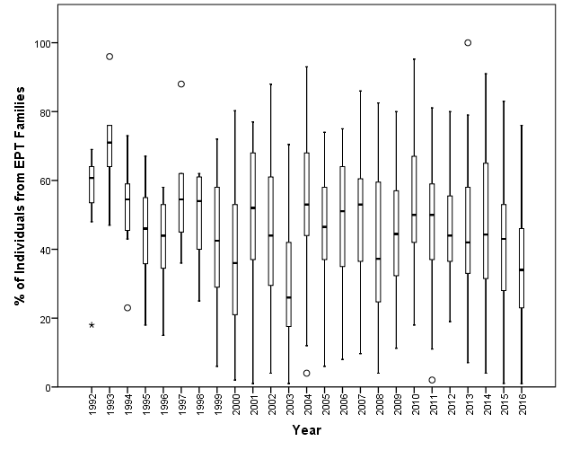

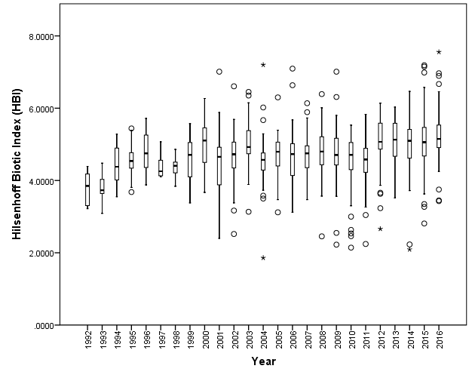

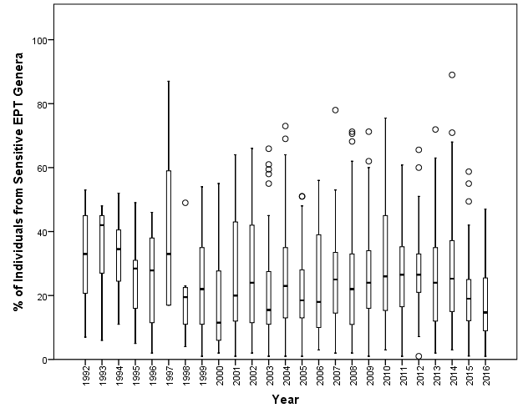

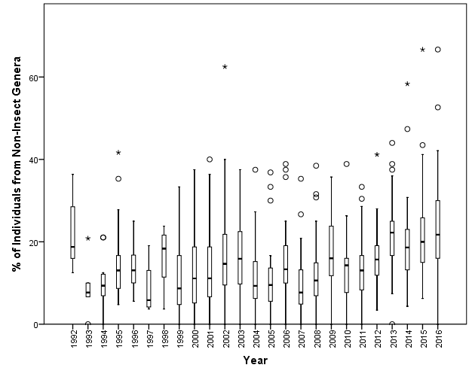

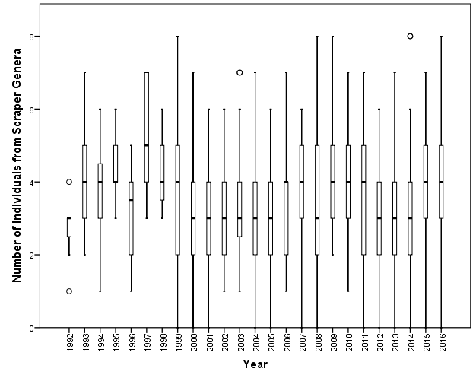

Should be number of Scraper Genera?

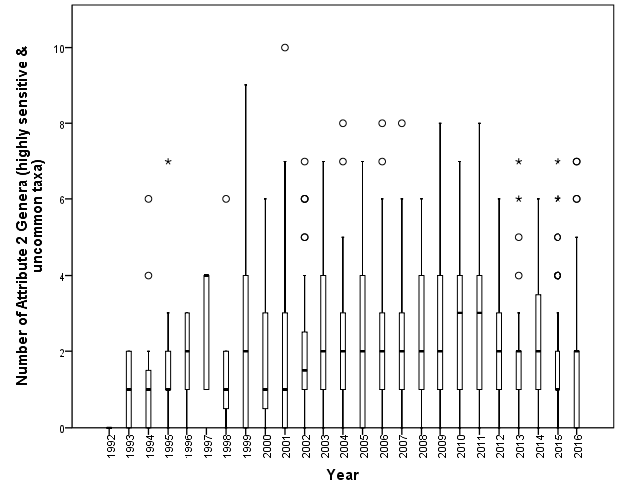

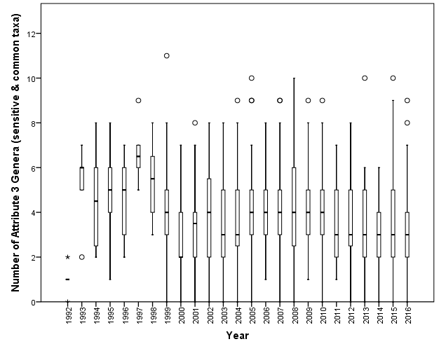

REDO with 2017 DATA Figure. Graph summary of counts of individual stream monitoring sites showing positive (increasing) trend, negative (decreasing) trend, and no change in each macroinvertebrate community metric over time.

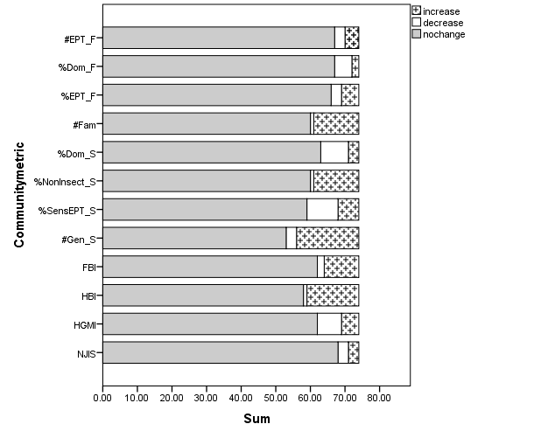

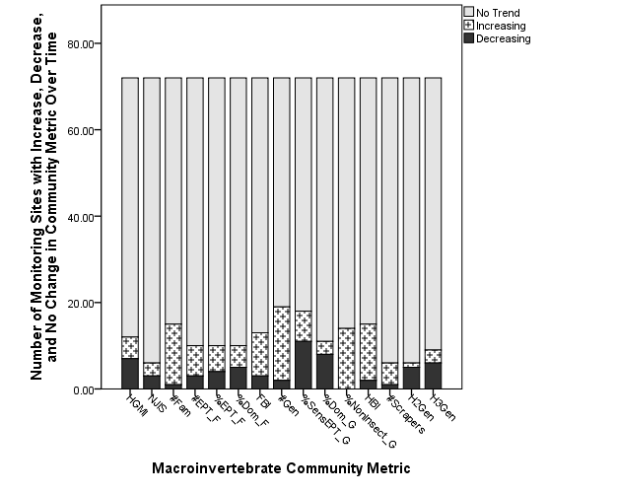

Change over time:
By site and combined overall: HGMI, NJIS, Number of EPT Taxa (can’t do this because we only collect the sample of 100), % of Individuals EPT Taxa, Shannon’s Diversity Index, Jaccard’s Index, and Bray Curtis Dissimilarity Measure, % of individuals Chironomid in relation to year. Year as grouping variable for the combined overall analysis for trends and/or multiple regression analysis.
By site and combined overall: Trends in Chemistry over time
By site and combined overall: Trends in select habitat variables over time
By site and combined overall: Trends in Land Use over Time
Explaining/Assigning Causality in Trends:
Multivariate analyses incorporating Local vs. Landscape Scale effects (time/year, chemistry, land use, habitat,
Group by Dominant Land Use and Compare Urban vs. Forest vs. Ag, any difference in diversity or community metrics
Compare before and after major storm events – AND Compare 1)years to reach 90% recovery of HGMI; 2)% recovery 2 years after storm. Also, test this using land use groupings; region groupings
Analyze stream standard deviation of mean and compare among site trends, regions, etc. this accounts for stream variability.
(Another paper? Look at community composition. Are there suburban, forest, agriculture stream communities? Discriminant Function analysis, PCA, CCA?)

Discussion:
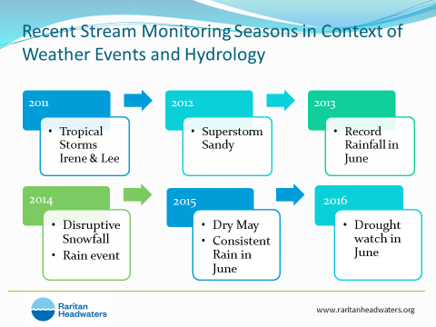
Literature Cited:

Appendices:

APPENDIX A:

STREAM MONITORING SITES – LOCATIONS, # OF YEARS, RANGE OF YEARS

APPENDIX B:
HGMI Algorithm metrics

