Water Quality Monitoring for Budd Lake, its tributaries and the mainstem South Branch Raritan River below Budd Lake
Mount Olive Township, NJ

(Criteria #9 of the Budd Lake Watershed Restoration and Protection Plan)

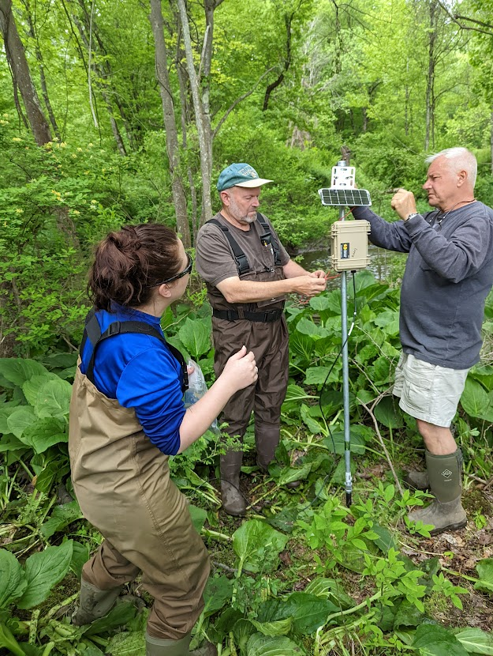

Prepared by: Raritan Headwaters Association
March 2023

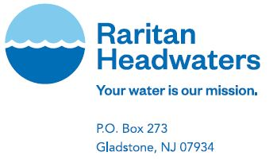

Cover photo by K. MacDonald; installation of Mayfly Enviro-DIY climate station RHA03 on the South Branch Raritan River just below Budd Lake

Goal: The goal of this monitoring plan is to assess the success of The Budd Lake Watershed Restoration and Protection Plan implementation in addressing stormwater inputs of nutrients, bacteria and other pollutants as well as impacts on temperature, dissolved oxygen, pH, dissolved salts, total suspended solids, HABs, and aquatic life within tributaries, the Lake, and just downstream on the South Branch Raritan River.

Monitoring Pre- and Post-WRPP Project implementation: RHA or consultant will collect water samples pre- and post-WRPP implementation during routine baseflow and after rainfall events. This monitoring plan will be revised and expanded as part of WRPP project implementation and grant submission.

Monitoring should be conducted twice per month from April – September to collect baseline readings. The trigger point/threshold for an additional sampling event, will be a rainfall event with at least 0.25 inches or more of rainfall within a 24 hour period. Samples will be collected 24 – 28 hours after a storm event at or above the threshold measurement, if conditions allow for safe collection procedures. During dry events or times where there may be minimal stormwater flowing out of the outfall pipe, surface samples will be collected just below the outfall pipes. Sampling protocols will be followed by the EPA Industrial Stormwater Monitoring and Sampling Guide (March 2009) (EPA, 2009).

To capture monthly accumulation of rainfall events, RHA staff or a consulting entity will reference the nearest CoCoRaHS station (https://www.cocorahs.org/; NJ-WR-5) and a monthly weather report from National Oceanic and Atmospheric Administration (NOAA). The trigger point/threshold for the sampling program to begin will consider a rainfall storm event with 0.25 inches or more of rainfall. Compilations of the amount of rainfall that occurs monthly within the sampling locations will be recorded and summarized in the final report. Volunteers within the municipality of Budd Lake will be encouraged to install a CoCoRaHS station on their property to assist with the development of the monitoring plan (the aim is 3 stations).

In situ monitoring (April – September): The following in-situ parameters should be tested at each sampling location (streams, lakes and outfalls) using YSI probes or equivalent: temperature, dissolved oxygen, pH, alkalinity, conductivity, and phycocyanin.

Grab samples for laboratory analysis: Samples will be collected twice per month under baseflow conditions and once per month During each sampling event in the lake only, grab samples will be collected and sent to a NJ-certified laboratory for enumeration and identification. During each sampling event in the lake and at SB21, samples will be collected and sent to a certified lab for cyanotoxin analysis. At all stream, outfall and lake sites, grab samples will be collected and sent to a state certified lab for analysis of total phosphorus, orthophosphorous, nitrate-nitrite, ammonia, total suspended solids, turbidity, conductivity, biochemical oxygen demand, and E.coli.

Annual Biological and Visual Habitat Assessments (Annual from June 1-Jun30): Macroinvertebrate and visual habitat assessments will occur only in streams. This will include a minimum of 3 tributaries to Budd Lake and will also continue at RHA’s longterm monitoring site SB21 on the mainstem South Branch Raritan River below the confluence with Budd Lake. Macroinvertebrate samples are collected, and visual assessments conducted on an annual basis between June 1st and 30th. RHA’s benthic macroinvertebrate sampling and visual habitat assessments have a DEP-approved QAPP conforming to Tier 3.3 level standards and are thus used by the DEP for regulatory decision-making (NJDEP Water Monitoring and Standards, Volunteer Monitoring, https://njwatershedwatch.org/wp-content/uploads/2021/01/NJ-Community-Monitoring-DataQuality-Tiers.pdf). Benthic macroinvertebrate samples are preserved and delivered to a certified taxonomist at Normandeau Labs in Pennsylvania for identification, counts and calculation of the High Gradient Macroinvertebrate Index (HGMI) and its submetrics.

All chemical, biological and visual habitat data will be entered into the NJDEP stream monitoring database and subsequently uploaded to the Water Quality Data Exchange (WQDE) for data sharing with the DEP, EPA and other users.

Sampling Locations Pre- and Post WRPP Implementation:

- Baseline Assessment of Budd Lake: To our knowledge, there has never been a comprehensive baseline water quality and hydrologic assessment of Budd Lake. Princeton Hydro is developing a plan for a baseline assessment of Budd Lake including data from sediment and water column samples to determine phophorous loadings present in the lake sediment and water. Additional parameters for the baseline will include nitrogen, temperature, pH, E. coli bacteria, TSS, turbidity, and specific conductance. The presence of contaminants in the lake may include PFAS, mercury, arsenic, cadmium and 1,4 dioxane as well as other potential contaminants. Lake depth and currents will also be determined. This study will represent WRPP pre-implementation conditions within Budd Lake and serve as a point of comparison for changes in water quality post-implementation.

- Monitoring Budd Lake post-project implementation: The baseline assessment of Budd Lake will inform in-lake monitoring that will occur once the WRPP is implemented. Because the baseline lake assessment has not yet been done, this is what we anticipate will be monitored and is subject to change. Historical records of previous lake management control efforts via algaecide applications, water quality monitoring, aquatic plant management, dredging, and other related lake management efforts will be compiled as part of the development of the watershed management plan. The current lake consultant (as of 2022), Aquatic EcoAnalysts, conducts algae and aquatic plant management monthly. Advanced notification will be required in coordination with the municipality and/or lake consultant when it is determined an algaecide or herbicide applications are to be performed. These applications could skew results of planned monitoring activities as described in this plan, monitors should plan to collect samples prior to application, if possible. An established GPS-referenced inlet station, lake station (deepest part of lake), bottom station (depth at lake station), and outlet station will be monitored monthly with a total of 6 sampling events (April – September) based on records. A Kemmerer would be utilized to collect samples at depth.

Table 1. Sample locations and Rationale
Location ID | Name | State Plane
 |  | Lat | Long
IS | Inlet Station
LS | Lake Station
LBS | Lake Station (Bottom)
OS | Outlet Station

- Monitoring Tributaries to Budd Lake: To identify the amount of nutrients entering Budd Lake, baseline monitoring needs to be conducted at several locations that flow into the basin. These stream monitoring sites (Table 3) are identified to capture the entire drainage area in the watershed while avoiding the mixing zone with the lake if feasible. According to USGS, six feeder streams filter through wetlands before entering Budd Lake. The following in-situ parameters should be tested at each sampling location at the outflow point: temperature, dissolved oxygen, pH, alkalinity, hardness and phycocyanin. Algae samples will be collected and sent to a NJ-certified laboratory for enumeration and identification. The following parameters should be collected on a bi-weekly basis from April – September and sent to NJ-certified lab: phosphorus, TKN, total suspended solids, and conductivity. Sampling should be conducted at the following locations listed below:

Table 2. Tributary and South Branch Monitoring Locations.
Location ID | Name | State Plane
 |  | Lat | Long
T1 | Tributary 1 (Black Brook)
T2 | Tributary 2 (unnamed South Branch Trib)
T3 | Tributary 3 (unnamed South Branch Trib)
SB4 | South Branch Raritan River Outlet
S21 | South Branch mainstem, RHA longterm monitoring site

- Monitoring Stormwater Outfalls to Budd Lake: There are 21 stormwater outfalls located along Route 46 and Sand Shore Road that flow into Budd Lake (see map in WRPP). An MS4 permit is needed which is a conveyance or system of conveyances (including roads with drainage systems, municipal streets, catch basins, curbs, gutters, ditches, man‐made channels, or storm drains) which are owned, operated, and created by or pursuant to State law (POTW). [40 CFR 122.26(b)(8)] (EPA, 2009). While the locations of the outfalls are mapped by the municipality, the drainage areas for each outfall are not yet mapped. Mapping of drainage areas will be completed within the next year by the municipality. In addition, outfalls that are owned by the NJDOT are not included in the map but should be targeted as part of the Plan.

All major roadways perpendicular to route 46, on the upland rise overlooking Budd Lake, end in stormwater outfalls into the stream. Department of Transportation (DOT) stormwater outfalls are also located along route 46 and in some places connect to the municipal stormwater system. Located across from the CVS, the stormwater drains eventually connect to state drains and lead to the shorelines of the lake. The culvert at this location is heavily clogged with sediment, which causes a backflow of stormwater and flooding during severe storms.

Stormwater outfalls are visible from the municipal beach, and scouring from water entering the lake after storms, as well as natural currents in the lake, are contributing to removal of sand from the beach and the need for periodic beach replenishment. The sand is washed downstream of the lake into the South Branch Raritan River.

Construction of major developments have taken place within the municipality of the Budd Lake Watershed over the past 2 decades. Most of the lakefront homes along Sand Shore Drive are on private well water and public sewer. However, most residences located uphill of the lake are on public water (municipal wells) and public sewer.

As part of this monitoring plan, a minimum of 6 stormwater outfalls should be sampled: BL26, BL24, BL15, BL19, BL6, and BL4.

- Monitoring the South Branch Raritan River below the confluence with Budd Lake:
RHA has a Mayfly Enviro-DIY climate monitoring station (RHA03) on the South Branch Raritan River just below the confluence with Budd Lake. The station collects and stores temperature, conductivity and depth data every 15 minutes and transmits it via cell service to MonitorMyWatershed.org linked on the RHA website here https://www.raritanheadwaters.org/climate-stations/

In addition, RHA has a longterm stream monitoring site (SB21) on the South Branch Raritan River below the confluence with Budd Lake where it collects chemical, biological, and visual habitat data annually. Data may be accessed here https://www.raritanheadwaters.org/watershed-report/

Data will continue to be collected at these sites using the protocols for streams outlined above.

Implementation Schedule by Objective
Some monitoring has already been implemented (RHA03 and SB21). The project schedule anticipates that the remainder of the monitoring will begin Spring 2023 (baseline, pre-implementation sampling) and extend at least 10 years post-implementation to Fall 2033. This is subject to changes pending funding.

Table 3. Implementation schedule by objective.
Task | Responsible  Party | Time  (months) | Project Deliverable | Status (start/end)
Budd Lake WRPP Monitoring Project QAPP Development | RHA | 1 | RHA Approved QAPP | underway | TBD
Obtain 319h grant for Budd Lake WRPP implementation (monitoring program) | - | - | - | TBD | TBD
Data Collection | RHA | 1200 (10 years) | Data Collection and Entry in WQDE, Tables, Charts | Partially underway | TBD
Data Analysis | RHA | Annual and at conclusion of project | Data Summary and Trend Analyses and Cumulative Annual Reports, Final Report (10 years) | TBD | TBD

References

Environmental Protection Agency. (July 1992). NPDES Storm Water Sampling Guidance Document. Retrieved from https://www3.epa.gov/npdes/pubs/owm0093.pdf.

New Jersey Department of Environmental Protection. (2005). Field Sampling Procedures Manual. Retrieved from https://www.nj.gov/dep/srp/guidance/fspm/.

New Jersey Water Monitoring Council. (2021). Decontamination Protocol Recommendations for Freshwater Monitoring (Draft).

Environmental Protection Agency (EPA). Industrial Stormwater Monitoring and Sampling Guide. (2009, March). Retrieved November 10, 2022, from https://www3.epa.gov/npdes/pubs/msgp_monitoring_guide.pdf

NJDEP Water Monitoring and Standards, Volunteer Monitoring, https://njwatershedwatch.org/wp-content/uploads/2021/01/NJ-Community-Monitoring-DataQuality-Tiers.pdf

